**Air Guitar Script**

Hi I’m Kim, Grand Wizard of Air Guitar, and me and this guy (pan to Brandon) we are looking to you to join our crew! [Scene 1]

You might ask who is Air Guitar? We’re a pair of entrepreneurs with a love for making sick awesome tunes (Guitar Shred)and the balls to push effects pedals up onto the cloud! ( Throws pedal upwards) [Scene 2] < Maybe add turn around transition >

It doesn’t matter if you’re a beginner ( Bad Shred), Semi-Pro ( Mid skill shred) or Professional (Ultra skilled shred) (Walk by panning). Air Guitar makes it easier and cheaper for anyone to create their own sick awesome tunes to appease the guitar gods!( take out money from pocket & Guitar shred again) [Scene 3]

So who are we looking for? Someone who specialize in the area of marketing, sales or development but most importantly someone who knows how to enjoy the finer things in life. (beer cheers! & drink)

So if you think you’re the perfect match for us then we ask you to send us your resume as soon as possible. We’re Air Guitar and we’re looking for someone to join us and we hope that it’s you! [ Scene 4 ]

/// DONE!

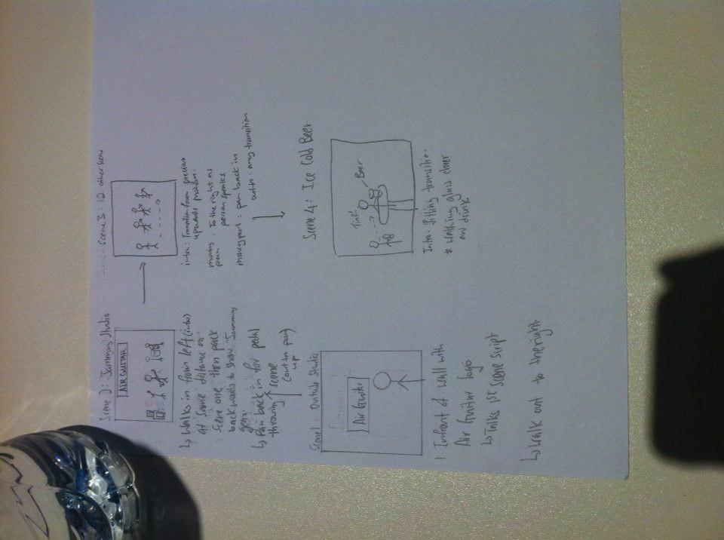

Welcome to Air Guitar HQ! (Guitar Shred) and here at Air Guitar we love making sick tunes (Alternate Guitar Shred) [Scene 1 – Jamming site]

You might ask yourself who is Air Guitar? We’re a group of entrepreneur with a knack for making awesome sick tunes

but we one problem we’re stuck with the pedals that we’ve bought and can’t make sicker tunes! ( GIANG GIANG!).

So we had an idea to put pedals into the cloud and anyone can pick which pedals they want to use and switch it up whenever they need to (Guitar shred success!).

It doesn’t matter if you’re a beginner ( Bad Shred), Semi-Pro ( Mid skill shred) or Pro (Ultra skilled shred). We want to make, creating your own tunes easier and cheaper and the same time appease the GUITAR GODS! All you have to do is plug your guitar (Guitar plugin quickcut), choose your pedals & start making guitar magic (Guitar shred).

So if you like our idea and love to join our band, we need a Lead Guitarist (Sales)! a Drummer(Marketing)! a Lead Vocalist ( public relations) and a pianist (developer) because he’s too busy making sick tunes! Join us Air Guitar – Your Sound, Your Music.